**Commodore PET IEEE-488 Extender – Riser Board Rev. 0**

**Module Description**

# Introduction

The IEEE-488 extender riser board is connected to either the base board with edge connector (Project 169) or the base board with Centronics connector (24p. = IEEE-488 connector, Project. No. 204). It serves for connecting IEEE cables with and edge connector or a peripheral like the SD2PET, which has an edge connector installed.

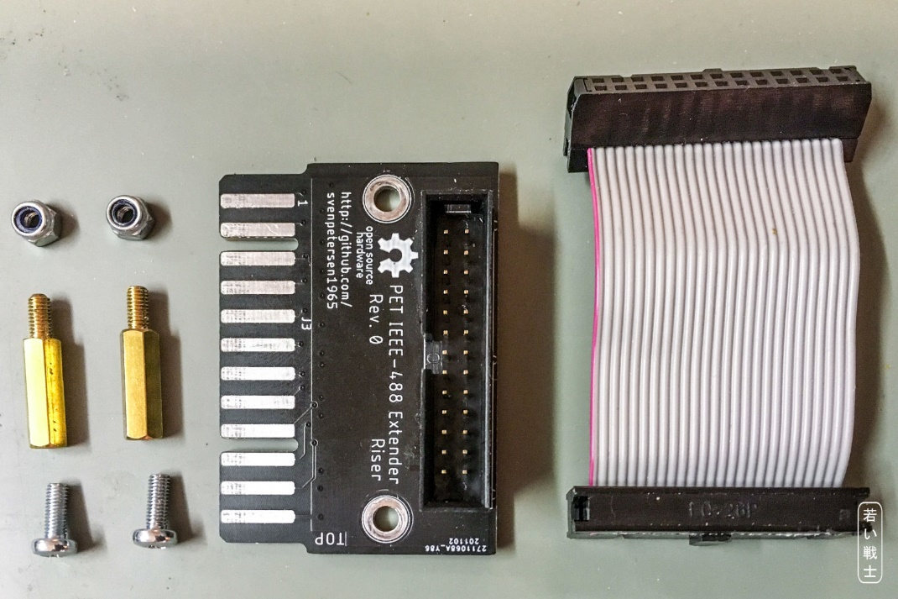

Figure 1: Riser Board with jumper cable and mounting material

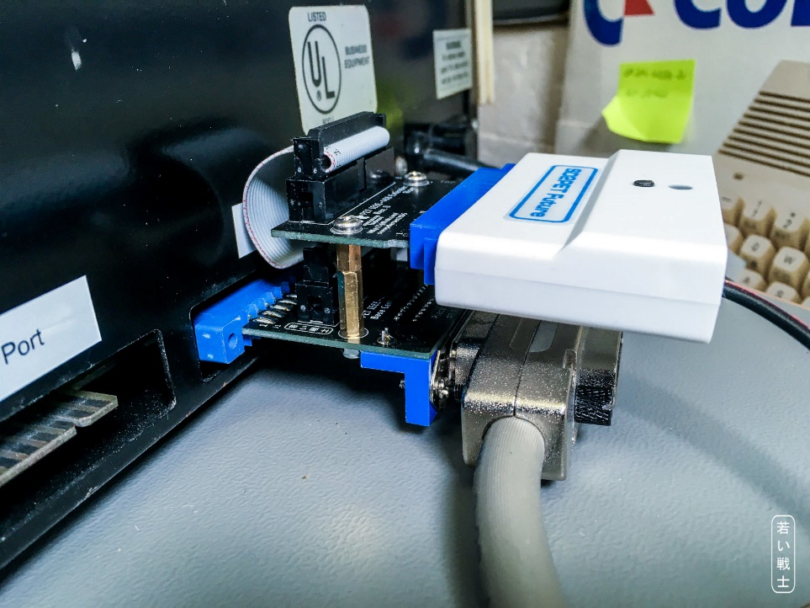

Figure 2: Riser Board on a Centronics Base Board with an SD2PET

# Dimensions

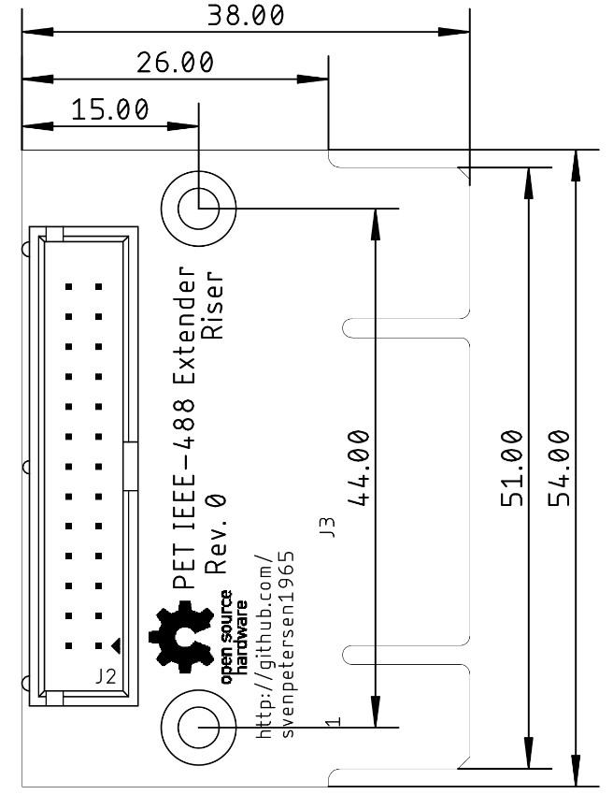

Figure 3: Dimensions of the IEEE-488 Extender

# Connectors

|  |  |  |  |  |  |
| --- | --- | --- | --- | --- | --- |
| J3/top | Signal | J2 | J2 | Signal | J3/bottom |
| 1 | DIO1 | 1 | 2 | DIO5 | A |
| 2 | DIO2 | 3 | 4 | DIO6 | B |
| 3 | DIO3 | 5 | 6 | DIO7 | C |
| 4 | DIO4 | 7 | 8 | DIO8 | D |
| 5 | EOI | 9 | 10 | REN | E |
| 6 | DAV | 11 | 12 | GND | F |
| 7 | NRFD | 13 | 14 | GND | H |
| 8 | NDAC | 15 | 16 | GND | J |
| 9 | IFC | 17 | 18 | GND | K |
| 10 | SRQ | 19 | 20 | GND | L |
| 11 | ATN | 21 | 22 | GND | M |
| 12 | GND | 23 | 24 | GND | N |
| - | GND | 25 | 26 | GND | - |

Table 1: IEEE-488 signal pinouts

**J3** is a card edge structure on the PCB, which connects to the IEEE-488 peripherals via the PET-IEEE-488 cable or directly (in case of the SD2PET future). **J2** is a 2x13 pin header/box connector for the jumper cable to the respective base board.

# Cable

The jumper ribbon cable connects J2 or the Riser Board to J2 of the desired base board. Since this cable is usually installed only once, there is no need for a strain relief. This way, the standoff between riser board and the base board can be 15mm only.

# 3D-Printed Case

The bottom Shell of the Case for the Centronics Base can be used to support the board stack.

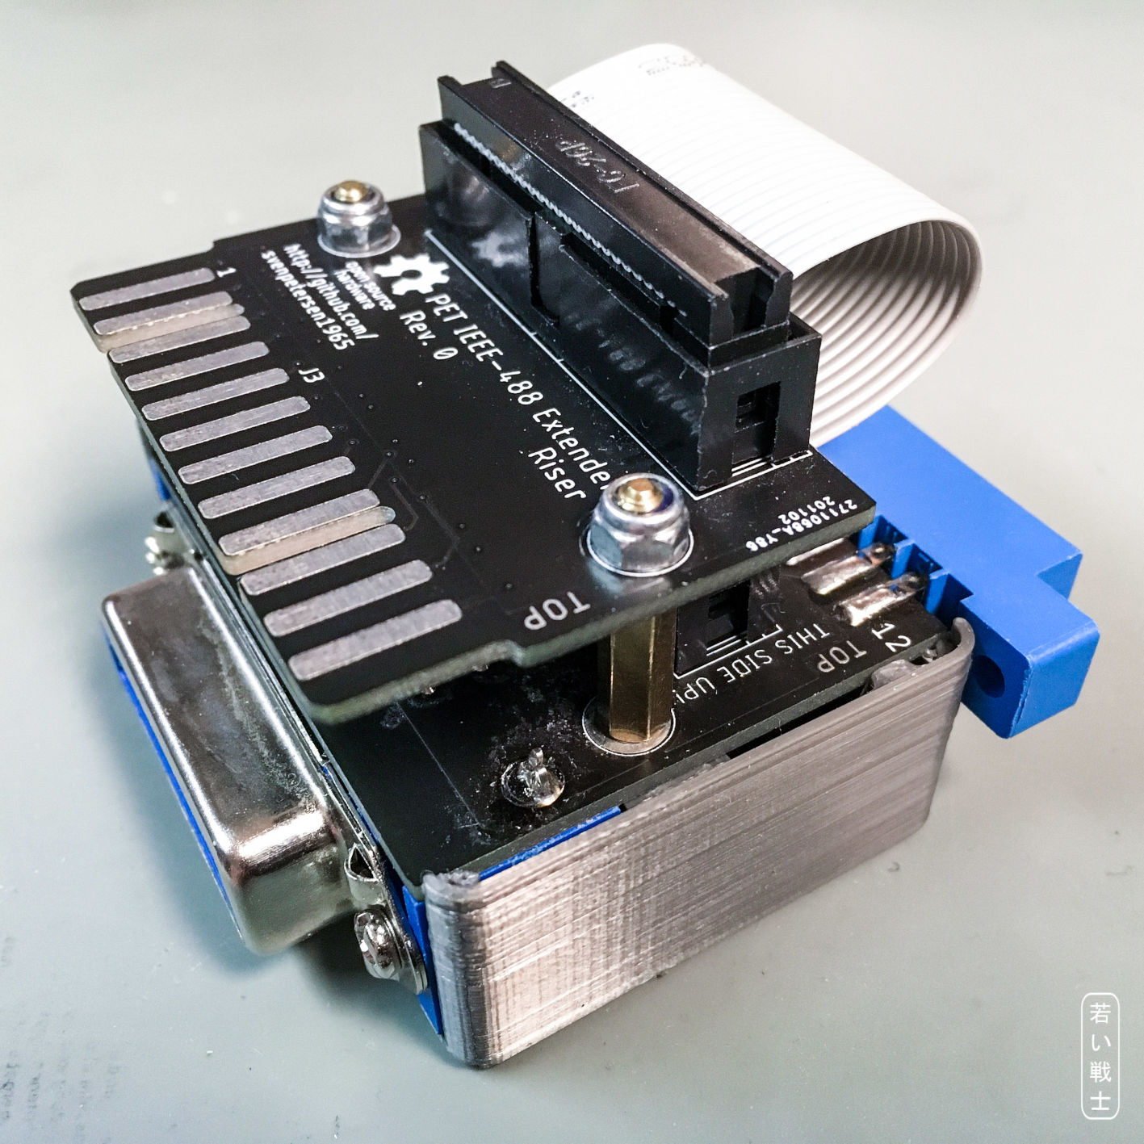

Figure 4: Board stack with Centronics Base and the bottom shell of the Centronics case

The recommended mounting material:

* 2x 15mm standoffs
* 2x M3x8 Screws (e.g. DIN 7985, Philips dead)
* 2x Nut M3 self-locking (DIN 985)

# Application Note

When using it as a splitter for the SD2PET, it is not tested to drive more than the SD2PET and one more peripheral. It is suspected, that the SD2PET is not capable to drive bussed with several devices.

# Revision History

## Rev. 0

* Prototype (fully functional)